# Setting up the Pi – LAMP WebServer

This tutorial will walk you through setting up Raspberry Pi as a LAMP server. Your Pi should already be fully functional – if you need to get set up, follow the first tutorial in this collection before embarking on this one.

**Materials**

1. Internet-enabled Raspberry Pi
2. Personal computer on the same network as the rPi

## Background

I spent many an hour (hour, bah, try months) going through my projects without understanding what a webserver is or how it works. I looked it up, and asked anyone with whom conversation veered toward the topic, but understanding evaded me. I found it frustrating, and hopefully this background section will ease the journey for anyone interested in the how and why of the following steps. If you aren’t interested in the academic details, feel free to skip to Step 1.

**What is a webserver?**

A webserver is a computer which is configured to hold the files for a webpage. Webserver software on that computer receives requests for pages, fetches them from the file system, and delivers them to the requesting machine – the client. Now, is the webserver the machine holding the files for the webpage, or the software managing the serving of the webpage? Both. The terms are used interchangeably.

Consider this paragraph from <http://whatismyipaddress.com/web-server>:

Every web page on the internet also has a unique address, called a Uniform Resource Locator, or URL. Something like "www.example.com/page1.htm" is an example of a typical URL. When a user types that URL into a web browser, the machine the browser is running on sends a request to the IP address of the machine running the web server for that page, requesting that all the content found there be sent back. Once the web server receives that request, it sends the page content back to the IP address of the computer asking for it. The web browser then translates that content into all of the text, pictures, links, videos, etc. that so many web pages contain.

Using their example of [www.example.com/page1.htm](http://www.example.com/page1.htm), example.com is the domain name. A DNS service (DNS is Domain Name System, and it acts a directory by mapping domain names to IP addresses) will translate example.com into an IP address. Then, a request for page1.htm will be sent to that IP address.

For more details, read through these two pages: <http://whatismyipaddress.com/web-server> and <http://www.cs.bu.edu/~best/courses/cs109/modules/getwebpage/>. They are both illuminating descriptions of this process. In essence, though, *a webserver is a machine holding files for a webpage, which has software that manages internet users who want to see the webpage*.

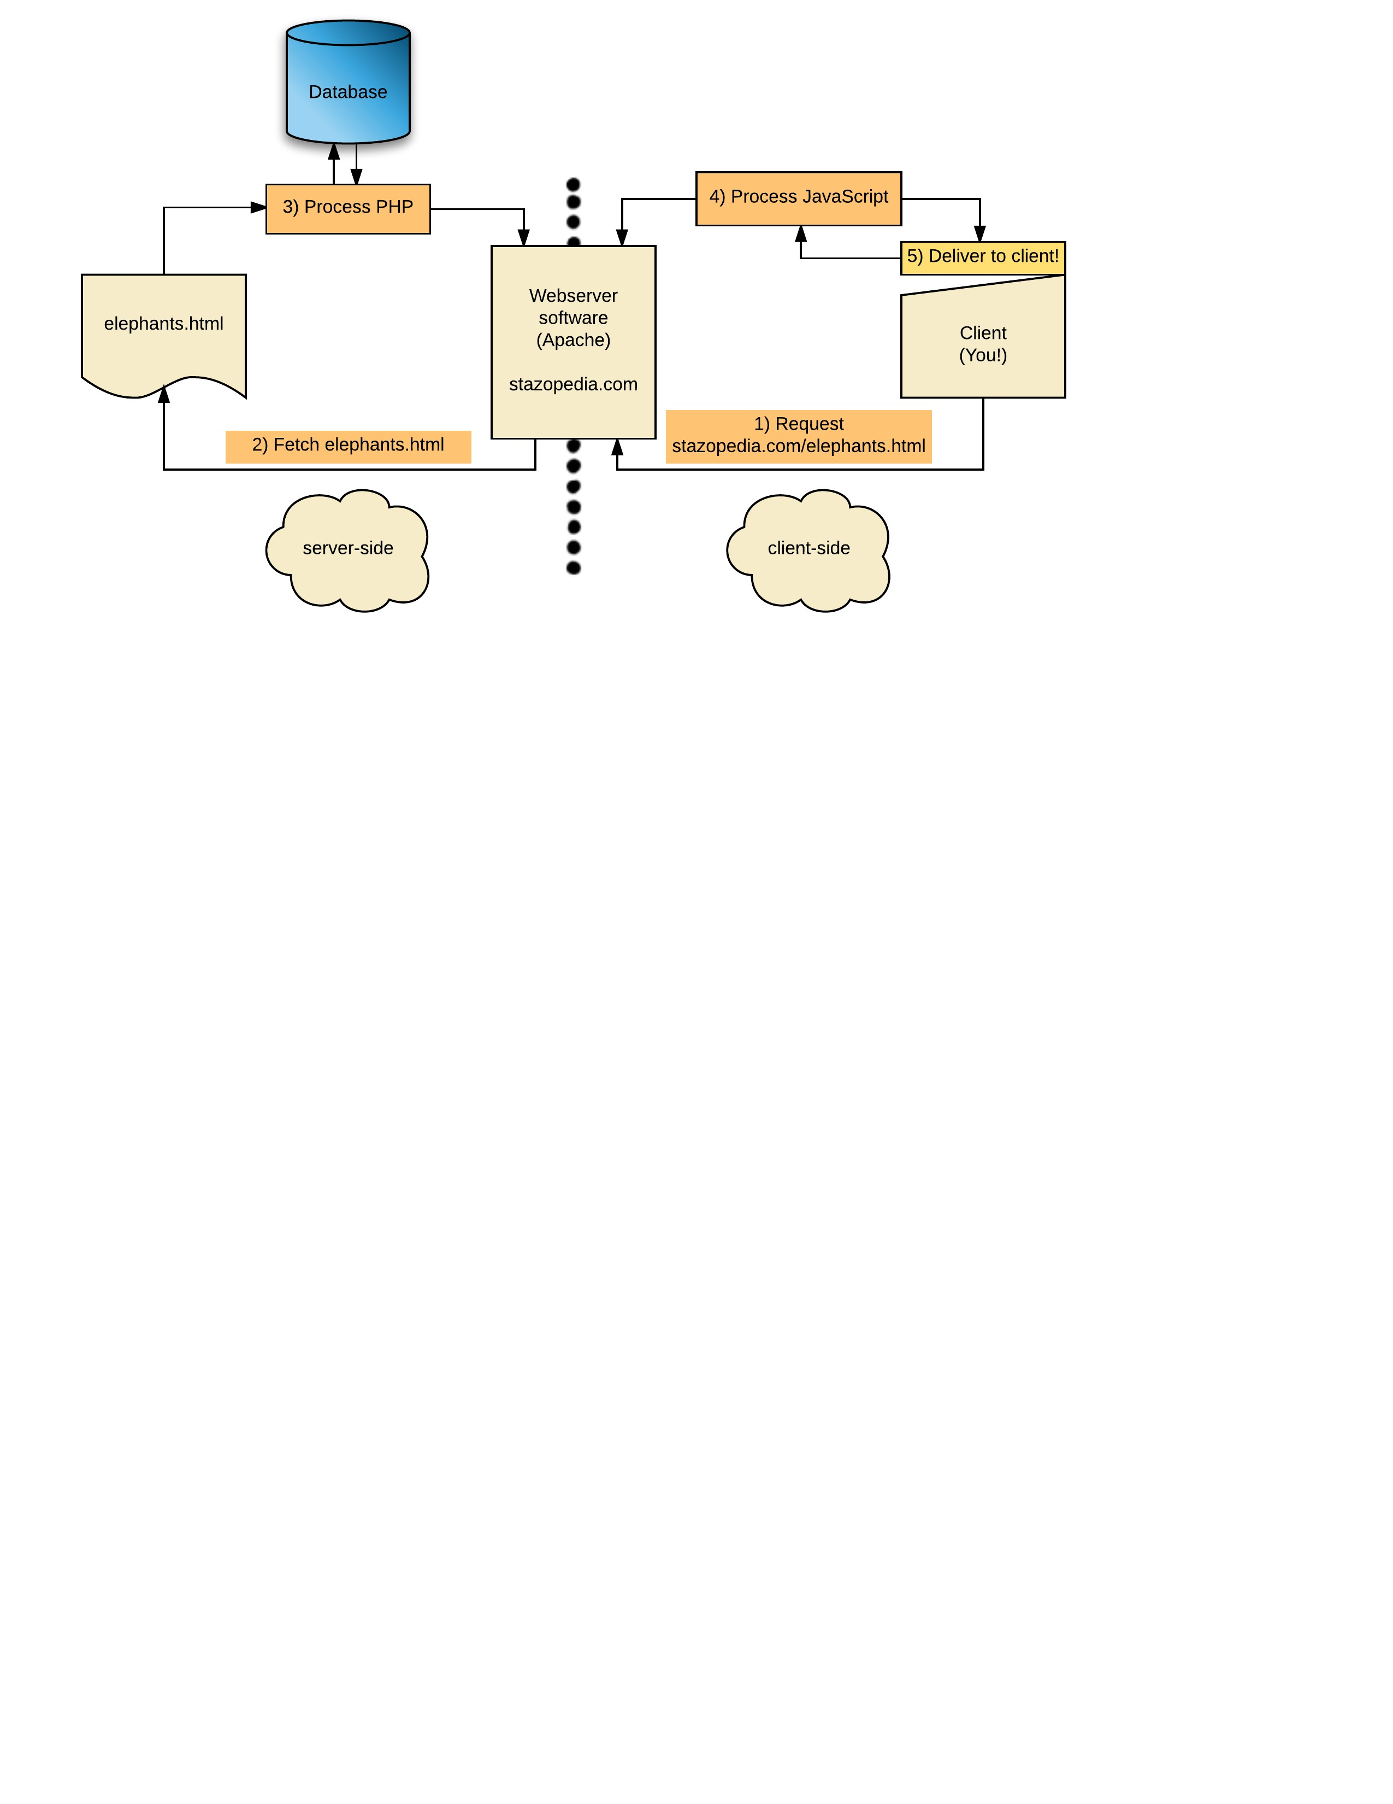

**LAMP**

LAMP stands for Linux Apache MySQL PHP, which are the components that go into hosting a website.

**Linux** is the distribution type. Raspberry Pi operating systems are almost exclusively Linux, so we are making a Linux server. Websites hosted on a Mac or Windows use MAMP and WAMP servers, respectively.

**Apache** is the software that makes a webserver a webserver. It is responsible for receiving requests, getting the appropriate file, and returning the file to the client.

**MySQL** is a database host. It stores your information and makes it available for you to change and retrieve. MySQL is a common choice, but is not the only option – in fact, this tutorial uses MongoDB.

**PHP** is a scripting language, and you embed it in the HTML files that compose your website. It is processed server-side, generating HTML, and then the fully-HTML page is sent back to the client. For very clear, short descriptions of what PHP is and how it differs from JavaScript (another very popular scripting language) visit <http://php.net/manual/en/intro-whatis.php> and <http://gpmwebsolutions.com/php-javascript-difference>.

## Step 1: A Barebones Webserver

As described above, Apache is the webserver part of this webserver tutorial. The steps after this one make the webserver capable of interesting functionality, but you’ll technically have a server (and be able to make a website) with just this step.

1. SSH into the Pi by executing the command ssh pi@ipaddress, where ipaddress is the static address you assigned in the first tutorial. The default login information is

username: pi

password: raspberry

1. Execute sudo apt-get install apache2
2. Check that it is working by typing the IP address into your computer’s web browser. It should say “It works!” in the browser window.

Ta-da, you have set up a webserver! Not very exciting, is it? Let’s do a little something to spice it up.

1. Navigate to /var/www/html and identify a file named index.html, the default page. Consider when you request a website, for example stazopedia.com – this website may have several pages, such as stazopedia.com/elephants, but the webserver still has to deliver something even when you don’t specify a particular page. So, it delivers index.html.
2. Add some code to index.html. With Apache you are HTML, CSS, and JavaScript enabled. W3 is an excellent resource for learning web development languages, in addition to general browser searches. Start here to learn how to use HTML: <http://www.w3schools.com/html/>, and CSS: <http://www.w3schools.com/css/>.
3. Create other pages, such as a file called elephants.html. To view a specific page, type ip-address/pagename in your web browser.
4. All in all, tinker around until you feel comfortable with HTML, CSS, and simple JavaScript!

I also provide some example code for the project demo at <https://github.com/WigginWannabe/qp16-fall>. Look inside the “step1” directory of the demo for the JS-, HTML-, and CSS-only portion of the page. Each of these steps builds on the functionality of this page. The code is simple, so after tinkering with the languages for a while you should be able to understand it. Feel free to copy it into your directory and change it for practice, if you don’t feel ready to start your project page.

Some suggestions (try making these features to get familiar with HTML, CSS, and JavaScript):

* A menu bar which links to different pages in your directory (dropdown, maybe?)
* Buttons with a javascript response to clicks
* A header (as a general rule, use classes and divs extensively – in this case, it will be helpful to make a header class so you can decorate it separately in CSS, perhaps with a logo)
* A table or list – you can wait on this one since you don’t have data to put in it yet, but it can’t hurt to look ahead

## Step 2: Make it Dynamic

With just Apache, you are limited to HTML, CSS and JavaScript. They are great, but the world is much bigger. Specifically, they can only deliver static content – it will be the same every time you visit it. If you want to display information like the date or time, or the number of donors that you have, anything that changes over time, that limitation is crippling. Now we will install PHP so that you can make your pages dynamic.

1. Execute sudo apt-get install php5 libapache2-mod-php5. You will have to type yes a few times. If you go view the page in your browser, nothing will have changed, because we need to make a file using PHP.
2. Move index.html to a new filename so we can create index.php.

|  |
| --- |
| Terminal  mv index.html indexCopy.html  sudo nano index.php |
| index.php  <?php     phpinfo();  ?> |

1. *Now* the browser should change, showing you some stats about your PHP setup.

**.php pages**

HTML files have .html, clearly. And PHP files use .php. PHP is embedded within HTML code, so changing to the .php filetype enables PHP capabilities – much of the code will still be HTML. In the steps above, we abandon index.html for index.php; this just means that our homepage now uses PHP. Any pages using only static content can still be .html.

It’s time to combine PHP and HTML! I had some trouble wrapping my head around PHP because it feel odd to me to switch between languages within a document. If that boggles you as much as it did me, be sure to look at the sample code in “step2” of <https://github.com/WigginWannabe/qp16-fall> and the W3School tutorial for it.

Some suggestions:

* A form (you don’t have a way to save the data yet, so try displaying the user’s selections somewhere)
* Use a built in PHP function, like sunrise, date and time, etc.
* Use the include capability of PHP to make your code into modules. For example, make a header file and include it at the top of every content page.
* “echo” html code while inside a php tag

## Step 3: Data

Adding things like the date and time are cool, sure, but practically – in real applications and projects – you want to use your own data. For that, PHP needs to receive information from a database. Enter MongoDB (for us, you are welcome to use any database you choose).

1. You probably guessed that we need some terminal commands involving apt-get install:

|  |
| --- |
| Terminal  Sudo apt-get install php5-dev  Sudo apt-get install php-pear  Pecl search mongo  Sudo pecl install mongo |

You may receive a warning that pecl/mongo has been deprecated in favor of channel:///mongodb. Just continue.

It will ask: **Build with Cyrus SASL (MongoDB Enterprise Authentication) support?**

Say [no]

1. We need to add “extension=mongo.so” to php.ini, as is suggested in the completion notice of the previous step. Execute sudo nano /etc/php5/apache2/php.ini and search for “extension=” by pressing ctrl+W (don’t use quotes in the search terms). Add the line at the bottom of this picture.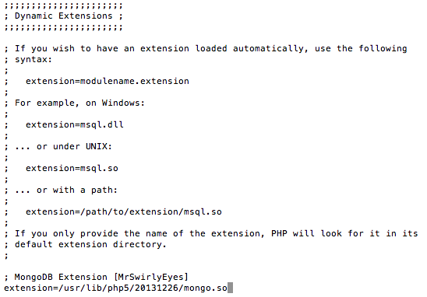
2. Restart Apache with sudo service apache2 restart
3. Go to mlab.com to make your database account. When you’re registered and signed in make a database.
4. Inside that database, at the top, it gives two options for connecting to it. We will be using the lower one, which looks like a URL.



1. Click on the “Users” tab and create a user. “admin” is sufficient for both username and password – this user is merely what you use for <dbuser> and <dbpassword> in the connection URL.
2. Go back to the “Collections” tab. Create a collection – call it anything, anything you want
3. Return to the pi and open a new .php file. In it, write

|  |
| --- |
| Anything.php  <?php  $db = new MongoClient([URL]); // paste your db URL  $collection = $db->[collectionName]; // paste  collection name  $newData = array( [key-value pairs] );  $collection->insert($newData);  ?> |
| ForExample.php  <?php  $connection = new MongoClient(“mongodb://admin:admin.blah”);  $db = $connection->qpdemo;  $collection = $db->hum;  $newData = array( ‘num’ => 130, ‘val’ => 57, ‘time’ => ‘8pm’);  $collection->insert($newData);  ?> |

1. Check out official PHP documentation for more about insert (<http://php.net/manual/en/mongocollection.insert.php)>. It will also be useful to familiarize yourself with functions like find, sort, and update.
2. Navigate to this page in your website. It should look like a blank page. Then refresh the mlab page, and you should see one document in your collection. Open it and take a look. It should look similar to this (values are not exactly the same as my array because this document is a measurement from my home sensor).  
   
3. Notice that every “key” => “value” pair in your array became a line in the database. This can get more complicated, with arrays inside arrays such as  
   

This is known as “JSON” format.

1. Finally, make these edits to your file. New information is in green. Notice that we are editing part of your old code – specifically, changing the number of the “num” value.

|  |
| --- |
| ForExample.php  <?php  $connection = new MongoClient(“mongodb://admin:admin.blah”);  $db = $connection->qpdemo;  $collection = $db->hum;  $newData = array( ‘num’ => 131, ‘val’ => 57, ‘time’ => ‘8pm’);  $collection->insert($newData);  $cursor = $collection->find();  echo “First loop: <br>”;  foreach ($cursor as $doc) {  echo $doc[‘num’] . “<br>”;  }  echo”<br>”;  $cursor = $collection->find(array(‘num’ => 131));  echo “Second loop: <br>”;  foreach ($cursor as $doc) {  echo $doc[‘num’] . “<br>”;  }  ?> |

1. Now refresh this file in your browser (aka visit it on your site). It will look similar to this picture:



When you visited the page, this file ran. First it inserted a file - we changed the number so that it wouldn’t be identical to the previous entry. It would have saved both documents because it assigns them different IDs even though the data is the same, but it would be harder to demonstrate with two identical documents!

Then it performed a find(). Find with no arguments gets every document in the file – that is why it returned both documents and prints both nums. The second find had a query which told it to only return documents where the num is 131. That is why it only returned one document. If you run this file again, there will be two listings in the second loop because it found two documents with num 131.

Sample mongo code is at <https://github.com/WigginWannabe/qp16-fall>, “step3.” At this point it isn’t gathering data from sensors, so the only data it stores and displays are user configurations. Try the radio and text forms to see php store the submission, and autofill based on database settings.

Some suggestions:

* Insert and update documents based on a form (inserting and updating are different! It is easy to overwrite a document instead of changing a part of it - you will probably have to try a few times before you get it right)
* Make a table or list by reading from Mongo (there is an example of this in the git repo. It isn’t inside a step. Look inside temperature.php or humidity.php)

## Conclusion

There you have it folks! Your webserver is completely configured – you can use HTML, CSS, JavaScript, PHP, and MongoDB to make your website interactive, useful, and pretty.

In the next tutorial, we use this website to control GPIO pins. The “General Purpose I/O” pins are one of the coolest things about Raspberry Pi; they transform it from a computer to a microcontroller.

## Resources

Apache and Webserver

<http://www.wpbeginner.com/glossary/apache/>

<http://gpmwebsolutions.com/php-javascript-difference>